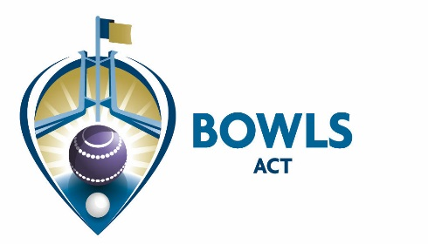

Address: PO Box 3607, Weston Creek ACT 2611 Email: admin@bowlsact.org.au
Phone: 02 5105 1083 Web: www.bowlsact.org.au
Facsimile: 02 6108 3557 ABN No.: 33 667 725 989
___________________________________________________________________________________________________________________

24 September 2019

CIRCULAR No 48 of 2019

TO: ALL CLUBS & MEMBERS

RE: DRAFT 2020 BOWLS CALENDAR

Attached is the draft 2020 Bowls Calendar for comment/feedback by 23 October. There are a number of things to note:
- The Pennant dates are tentative only, as it will depend on the number of entries/grade nominations etc we receive.
- The change to the Bowls Australia Calendar has necessitated the playing of certain events earlier than previously.
- No rep-representative dates or BPL Cup dates are included, as yet.
- No Club fixtures (except those already advertised) are included. Clubs are requested to advise us of known commitments as soon as possible to get the dates locked in.
Comments by email only, please. exec@bowlsact.org.au

Kate Lyttle
Executive Officer

