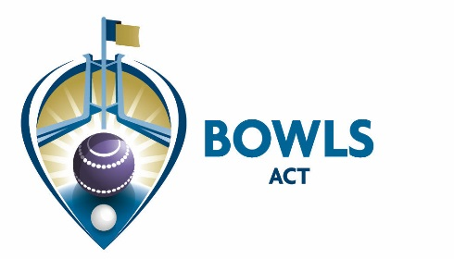

Address: PO Box 3607, Weston Creek ACT 2611 Email: admin@bowlsact.org.au
Phone: 02 5105 1083 Web: www.bowlsact.org.au
Facsimile: 02 6108 3557 ABN No.: 33 667 725 989
___________________________________________________________________________________________________________________

30/09/2019
CIRCULAR No 50 of 2019

TO: ALL CLUBS

RE: ACT Men’s and Women’s 60+ Pairs Event Open

The ACT 60+ Pairs Men and Women's are open to all bowlers registered with Bowls ACT. Bowlers must be from the same club to enter.
Dates of play: Men - 12th & 13th November; Women 13th & 14th November

Venues: To be advised

Entries Close 5:00pm Wednesday 23rd October 2019 .

Entries must be made online via the following link.
http://www.bowlsact.org.au/act-mens-womens-over-60s-pairs/

Payment $15 per player. Payment must be made to Bowls ACT by COB Wednesday 23rd October 2019.

Payment Methods - Cheque: Payable to 'Bowls ACT'. Credit Card via phone 5105 1083. Cash, Credit Card or EFTPOS in person to the Bowls ACT Office, MaClaurin Cr, Chifley.
Direct Debit - Account Name: Bowls ACT, BSB 062-907 Account No. 1023 5814 (N.B . Please advise Bowls ACT when a 'Direct Debit' is made and include the players name in the text). The Entry Form becomes a Tax Invoice for GST purposes once payment is received in full by Bowls ACT.

Opening hours 9.00-5:00 Mon-Thurs – (if visiting we recommend calling prior!)

Jenny Clout
Admin Officer

