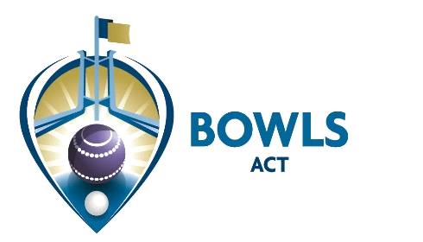

Address: PO Box 3607, Weston Creek ACT 2611 Email: admin@bowlsact.org.au
Phone: 02 5105 1083 Web: www.bowlsact.org.au
Facsimile: 02 6108 3557 ABN No.: 33 667 725 989
____________________________________________________________________________________________________________________

26 March 2020

CIRCULAR No 15 of 2020

TO ALL CLUBS AND MEMBERS

Re: UPDATE on BOWLS ACT OPERATIONS

As suspected, it appears that the COVID-19 issue is going to be with us for a considerable length of time. As a result, the following is provided for the benefit of member clubs and players:

- The halt on all Bowls ACT events will be extended to the end of August (subject to any further changes) It is highly unlikely that any of these events will be able to be played for 2020. Our first priority, if and when play is able to be resumed, will be to complete the Men’s and Women’s Pennant and ACT Singles, but of course there is no guarantee that we will be able to do so.
- Access to the Chiefly Community Centre has now been closed to members of the public. I will continue to work, from home, whilst this is functional. The best way to contact the office is through email, as the phone reception is proving to be patchy.
- The AGM scheduled for 28 April has been postponed. Although required by the Association’s Act to hold an AGM within 5 months of the end of the financial year, we have been advised that this period is likely to be extended by 2 months. In any case, ASIC has announced a “no action” policy if Companies are not able to hold their AGMs within the required time frames. They expect state Associations’ regulators will adopt the same policy. It is anticipated that when we do hold the AGM, it will be in the form of an electronic meeting. We will advise of the new date in due course.
- I will be in touch regarding refunds to those people who have entered and paid for events that will now not be going ahead.
- The health and wellbeing of members is crucially important. Please use this ‘down time’ to keep in touch with your team mates, many of whom may be feeling the loss of their bowls interactions quite severely.

Kate Lyttle
Executive Officer

